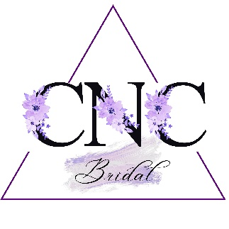
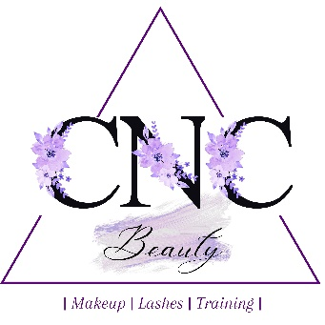

Terms and Conditions
Bookings
Bookings can be made by contacting me via email, telephone or the enquiry form on my website.

Booking Fees
If I have your date available, I will require a non-refundable booking fee of 50% off the total invoice. This secures your wedding day and is deducted from the final balance. Your booking fee must be received within 21 days of you confirming you would like to proceed. If it is not received within 21 days, your date will be released.

Final Balance
Your final balance is due in full a minimum of 48hrs prior to your wedding date. Full payment may be requested if your wedding date is less than 3 months away.

Makeup Rehearsals
Makeup rehearsals are booked as a separate date and I advise you book them anywhere from 1-3 months prior to your wedding date. When booking a makeup rehearsal, it must be secured with a non-refundable booking fee of 50% of the total invoice. The balance can be paid either in advance or on the day. I advise you book a makeup rehearsal as soon as possible to ensure you receive your preferred date. I cannot guarantee weekend appointments are available for rehearsals due to weekends being my busiest time with weddings. Makeup rehearsals will take place at my makeup studio in Lordswood, Chatham. I can travel out, however, this will incur a £20 call out fee plus the travel expense of 40p per mile from my studio location. Makeup rehearsals will be undertaken as a complete look.

Amendments to Bookings
Booking fees taken for your booking are non- refundable. If you wish to reduce the size of your booking, booking fees will not be refunded. Lost booking fees cannot be used to pay towards any outstanding balance for services still taking place. If you wish to increase the size of your booking extra non-refundable booking fees will be required.

14 Day Cooling off period
If you decide you do not want to go ahead with the booking, within the first 14 days (day 1 from when you contacted Chloe to book, not when deposit was sent), a full refund will be sent back to yourself.

Cancellation by you
In the unlikely event that you need to cancel your booking, you must do so at least 8 weeks before the confirmed rehearsal or wedding date, in writing and with a telephone call. Cancellations made after this time will be subject to a 50% payment of all outstanding fees. Any cancellations made within 4 weeks of the confirmed rehearsal or wedding date will be subject to 100% payment of all outstanding fees.

Cancellation by me
In the unlikely event that circumstances beyond my control force me to cancel, I shall always try to find a replacement makeup artist. If this is not possible, I will always offer you a full refund of all monies paid.

Liabilities
In all circumstances, the limit of liability for both parties will be no greater than the total cost of the booking.

Under 18’s policy
Every child under 18 years of age who wishes to have either Beauty or Makeup services must complete a declaration form (a signed letter of consent from the Legal Guardian). This must be signed by their legal guardian who will act as their guarantor for any booking contract with CNC Beauty. Please note services will not go ahead until this permission agreement has been signed, regardless of whether payment has been made or not.

Agreed timings
My quoted price for your booking will have been calculated with consideration to unsocial hours if applicable and a specific start and finish time. It may not be possible for me to stay longer than agreed if I have another client to accommodate after your booking. In the event that I am able to remain with you for longer than planned due to circumstances including but not limited to; extra waiting time between working on members of your party or late start due to you not being ready or at the agreed location on time, a fee will be chargeable of £25 per extra hour or part thereof.

Other Fees
CNC Beauty has no hidden fees, all charges will be made clear to you at the time of booking including travel and parking expenses. The only time this will not be made clear is if I arrive at your location and only paid parking is available. In this situation, you will be made aware as soon as possible and parking expenses will be invoiced to you. Travel expenses will be calculated based on your location.

Photography
By allowing me to take pictures on your makeup rehearsal and wedding day, you are agreeing to allow me to use these pictures for promotional purposes; including, but not limited to, my website and social media accounts. Pictures of your decided look taken at the trial will not be published until after your wedding day unless authorized by you to ensure your look is not revealed before you are ready.

Your contract with me
By entering into an agreement with me for professional services, you hereby agree to abide by and be bound by these terms and conditions. I reserve the right to alter these terms and conditions without prior notice; however I will always honour terms and conditions agreed with you when your booking was agreed.

Under new GDPR laws, you are required to agree for me to keep your information on file. Please select yes or no to the following:

Do you consent to me keeping your personal contact details on file… Y / N
Do you consent to me sending text messages and emails with information relevant to your services Y / N
Do you consent to any pictures taken being used for promotional purposes including but not limited to my social media paged, website etc. Y / N

Signed ………………………………………………………………………….

Date ………………………………………………………………………

