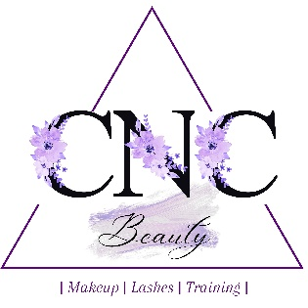
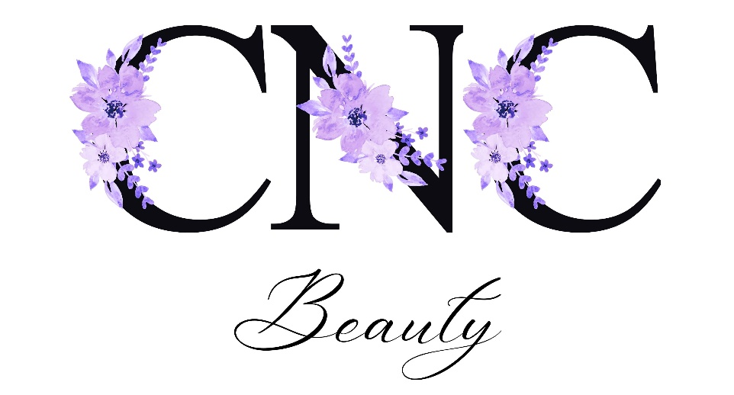

Terms and Conditions
Beauty service booking fees
Bookings must be secured by paying a non-refundable 25% deposit at the time of booking. Lost booking fees cannot be used to pay towards any outstanding balance for services still taking place. If you wish to increase the size of your booking, extra non-refundable deposits will be required.

Balance payment
Final service balances are to be paid in full on the day of your appointment. This can be paid via cash or card. I will also accept bank transfers however this must be paid and prior to you leaving the salon.

Cancellation or amendment by you, lateness & no shows
In the unlikely event that you need to cancel your booking, you must do so at least 48 hours before the confirmed treatment date. Cancellations or amendments made after this time will result in the loss of your booking fee and a new booking fee will be required for your next appointment. Date changes must be rescheduled within 2 weeks of the original booking date. If you are late to your appointment, you will lose time from your service and full payment will still be due. I reserve the right to refuse service if you are more than 15 minutes late to your appointment. In this case, your booking fee will not be refunded or transferred. If you do not turn up for your appointment without prior notice you will lose your booking fee and will be unable to transfer it to another date.

Cancellation by me
In the unlikely event that circumstances beyond my control force me to cancel your booking, I shall always offer you an alternative date, if this is not suitable, you will receive a full refund of the booking fee you paid to secure your booking. This decision must be made at the time of changing the date.

Raising Issues
You will be issued with aftercare advice at your appointment which should be followed to get the most from your service. If you have not followed your aftercare advice, I will be unable to fix any issues. I guarantee my work for 48hrs. I will not accept liability to fix any issues if my work has been touched by a third party. In the unlikely event that you should have any problems with the service you have received, I will require you to notify me with photographic evidence within 48hrs. I will arrange a time for you to come in for me to look at the issue in further detail. I do not offer refunds however I will fix the issue if required. Issues raised after 48hrs will not be covered by my guarantee. If you have been offered a slot to come in for me to have a look, you must come in within 7 days of the original service date.

Client Record Cards
You will be asked to complete a client record card at your first appointment, each appointment after this you will be required to update and re-sign. Record cards are only seen by myself unless required in case of emergency or for insurance reasons. I am required to keep record cards for 7 years by my insurance company. By having a service, you authorise me to keep these records.

Liabilities
In all circumstances, the limit of liability for both parties will be no greater than the total cost of the booking.

Under 18’s policy
Every child under 18 years of age who wishes to have either Beauty or Makeup services must have a signed declaration form. This must be signed by their parent or legal guardian who will act as their guarantor for any booking contract with CNC Beauty. Please note services will not go ahead until this permission has been signed, regardless of whether payment has been made or not.

Your contract with me
By entering into an agreement with me for professional services, you hereby agree to abide by and be bound by these terms and conditions. I reserve the right to alter these terms and conditions without prior notice; however I will always honour terms and conditions agreed with you when your booking was agreed.

Under new GDPR laws, you are required to agree for me to keep your information on file. Please select yes or no to the following

Do you consent to me keeping your personal contact details on file… Y / N
Do you consent to me sending text messages and emails with information relevant to your services Y / N
Do you consent to any pictures taken being used for promotional purposes including but not limited to my social media paged, website etc. Y / N

Signed ………………………………………………………………………….

Date ………………………………………………………………………

